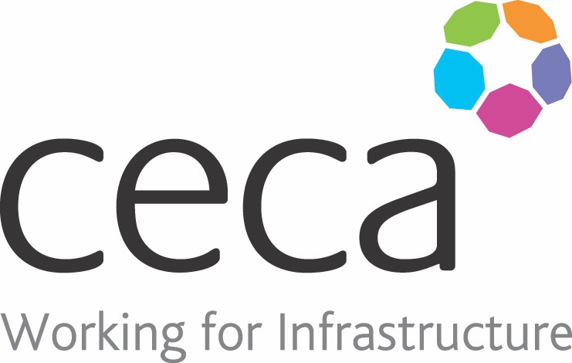
CECA Midlands E Learning

MENTAL HEALTH AWARENESS
Mental health has become far less of a ‘taboo’ subject in recent years. This training raises awareness of mental health (particularly stress, depression and anxiety), provides tools and guidance for daily wellbeing-management, and aims to remove the stigma surrounding mental health.
Mental Health is a serious subject. Nearly two-thirds of people say that they have experienced a mental health problem and evidence suggests that poor mental health is responsible for almost 13% of all sickness absence days in the UK.
One of the biggest challenges with poor mental health is removing the stigma that surrounds it. Many don’t hesitate to seek help for a physical pain or problem, yet so many of us ignore emotional and mental health issues – or we feel too embarrassed, confused or scared to talk about them.
This Mental Health Awareness course discusses mental health the way you would a headache or the flu, and it encourages you to take care of yourself as you would a loved one. It explains how to approach mental health and remove stigma; and it also provides simple tools, tips and ideas for day-to-day wellbeing-management (for yourself and others).
Happy staff equal healthier, more productive and more successful staff.
Put simply, good mental health is a win-win for every employee and their organisation.
Learning overview:
- Mental health awareness
- Mental health problems
- Wellbeing toolkit
- External help

Assessment:
This training programme concludes with a 20 question multiple choice test with printable certificate. In addition, brief in-course questionnaires guide the user through the sections of the training, and are designed to reinforce learning and ensure maximum user engagement throughout.

Cost: Registration fee £20 + VAT for full and associate CECA Midlands members.
Award: E learning certificate

Company name: |  | Company contact name:
Company email: |  | Contact tel:
Delegate name: |  | Job title:
Delegate email: |  | Delegate tel:
Accounts Name: |  | Accounts email:

Booking Form – please complete and return to admin@cecamidlands.co.uk one per delegate.
MENTAL HEALTH AWARENESS

