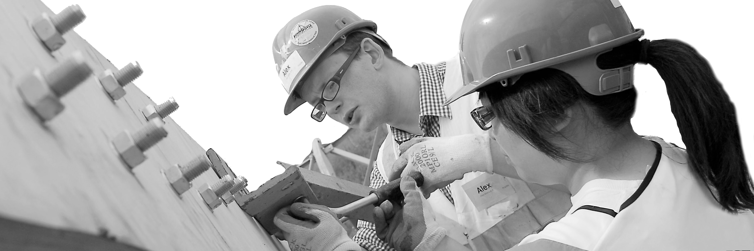
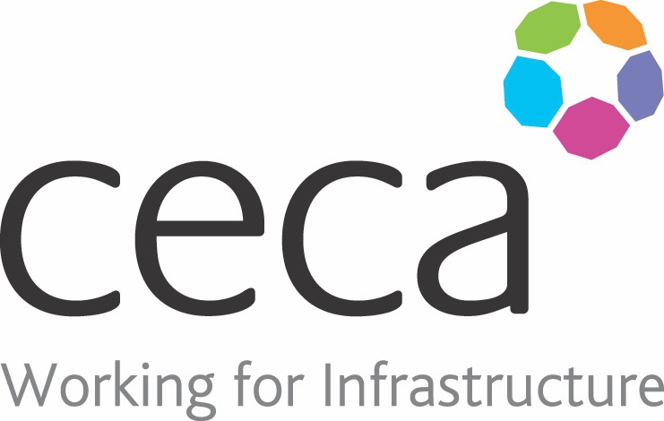
CECA Midlands E Learning

MENTAL HEALTH IN CONSTRUCTION
Mental health problems in the construction industry account for over 200 suicides and over 400,000 lost working days per year, let alone the mistakes and poor workmanship that can go with the symptoms.
In common with service personnel, construction workers whilst being prone to stress, anxiety and depression for a number of different reasons, frequently don’t want to admit to having problems, often until things have gone too far and medical intervention is required .
As a predominantly male industry, this ‘macho can put pressure on workers to ‘suck it up’ and get on with things, even if they are really struggling.
Our Mental Health in Construction course is split into 4 easy-to-follow and engaging sections which aim to educate learners on the various types of mental health problems, the science behind and where to go to for external help. The course also puts a strong emphasis on breaking the stigma surrounding mental ill-health throughout.
Learning overview:
- Mental health in construction
- Mental health problems
- Wellbeing toolkit
- External help

Assessment:
This training programme concludes with a 20 question multiple choice test with printable certificate. In addition, brief in-course questionnaires guide the user through the sections of the training, and are designed to reinforce learning and ensure maximum user engagement throughout.

Cost: Registration fee £20 + VAT for full and associate CECA Midlands members.
Award: E learning certificate

Company name: |  | Company contact name:
Company email: |  | Contact tel:
Delegate name: |  | Job title:
Delegate email: |  | Delegate tel:
Accounts Name: |  | Accounts email:

Booking Form – please complete and return to admin@cecamidlands.co.uk one per delegate.
MENTAL HEALTH IN CONSTRUCTION

