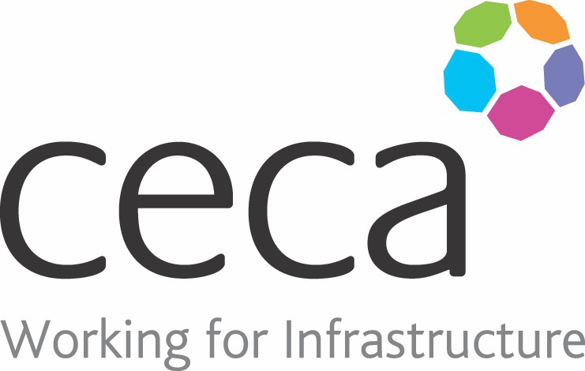
CECA Midlands E Learning

MODERN SLAVERY AWARENESS
Modern Slavery is an on-going issue within the United Kingdom and it is a crime. It includes slavery, human trafficking, forced or compulsory labour and servitude. People subject to slavery have to work against their will and do not have freedom of choice.
UK Law requires large companies to produce evidence of compliance both for itself and its supply chain and so even smaller companies will have to prove that training has been given to its workforce.
This online Modern Slavery training course aims to educate users on identifying signs of modern-day slavery and to give confidence to people to speak up about it.
Learning overview:
- Modern slavery spectrum
- You and your organisation

Assessment:
This training programme concludes with a 20 question multiple choice test with printable certificate. In addition, brief in-course questionnaires guide the user through the sections of the training, and are designed to reinforce learning and ensure maximum user engagement throughout.

Cost: Registration fee £20 + VAT for full and associate CECA Midlands members.
Award: E learning certificate

Company name: |  | Company contact name:
Company email: |  | Contact tel:
Delegate name: |  | Job title:
Delegate email: |  | Delegate tel:
Accounts Name: |  | Accounts email:

Booking Form – please complete and return to admin@cecamidlands.co.uk one per delegate.
MODERN SLAVERY AWARENESS

