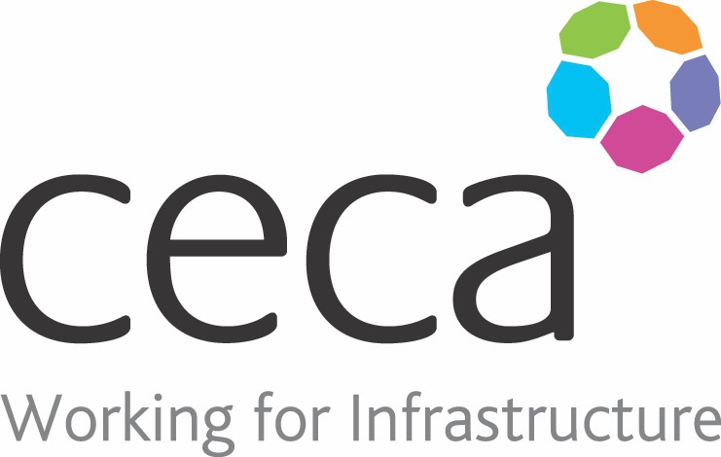
CECA Midlands E Learning

NEW AND EXPECTANT MOTHERS AT WORK
It’s important that the workplace is safe for everyone but special consideration must be made for the safety of new and expectant mothers at work.
Every year around 350,000 women in the UK continue to work after becoming pregnant and around 250,000 return to work after having their baby.
This New & Expectant Mothers Training Course has been designed to be used by employers, managers, expectant mothers and women returning to work after having a baby. It looks at the increased risks that pregnant women and new mothers may face and it looks at dealing with these risks in practical terms in the workplace.
It also looks at the risk assessments that need to be carried out and looks further into maternity rights, leave, pay and maternity allowance – all things that need to be considered.
In 2016 the Citizens Advice Bureau reported that it had seen a 58% increase in maternity leave queries in just 2 years – Take a look at the 10 most common examples of workplace maternity discrimination and make sure you avoid any similar scenarios with our New and Expectant Mothers at Work Training.
Learning overview:
- Risk assessment
- Workplace risks
- Equality and the law

Assessment:
This training programme concludes with a 20 question multiple choice test with printable certificate. In addition, brief in-course questionnaires guide the user through the sections of the training, and are designed to reinforce learning and ensure maximum user engagement throughout.

Cost: Registration fee £20 + VAT for full and associate CECA Midlands members.
Award: E learning certificate

Company name: |  | Company contact name:
Company email: |  | Contact tel:
Delegate name: |  | Job title:
Delegate email: |  | Delegate tel:
Accounts Name: |  | Accounts email:

Booking Form – please complete and return to admin@cecamidlands.co.uk one per delegate.
NEW AND EXPECTANT MOTHERS IN THE WORKPLACE

