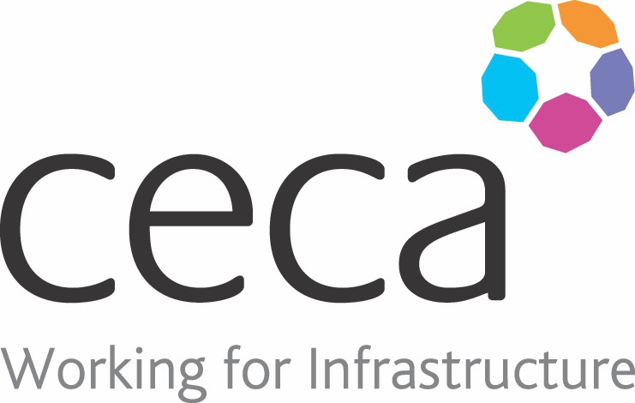
CECA Midlands E Learning

NOISE AWARENESS
Regular exposure to loud noise can affect your hearing. This noise awareness training programme looks at who’s at risk, what those risks are, and how to reduce them.
More than 11 million people in the UK suffer with forms of hearing loss and over 900,000 people are profoundly or severely deaf.
This online course looks at how your ears work to illustrate how delicate they are, how easily they can be damaged, and why noise-damaged hearing loss is permanent. It covers safe noise exposure levels and looks at what can be done to reduce exposure to regular loud noise or to sudden extreme noise.
This training programme will help you to recognise the early warning signs of hearing loss, so that something can be done before it’s too late. High-risk environments for noise exposure include Construction Sites, Factories or Industrial production lines, and some Hospitality venues (nightclubs, live music etc).
Due to abrasive wheels emitting high levels of noise, this noise awareness course works perfectly alongside our Abrasive Wheel Safety Course!
Learning overview:
- The ear
- Responsibilities
- Hearing protection

Assessment:
This training programme concludes with a 20 question multiple choice test with printable certificate. In addition, brief in-course questionnaires guide the user through the sections of the training, and are designed to reinforce learning and ensure maximum user engagement throughout.

Cost: Registration fee £20 + VAT for full and associate CECA Midlands members.
Award: E learning certificate

Company name: |  | Company contact name:
Company email: |  | Contact tel:
Delegate name: |  | Job title:
Delegate email: |  | Delegate tel:
Accounts Name: |  | Accounts email:

Booking Form – please complete and return to admin@cecamidlands.co.uk one per delegate.
NOISE AWARENESS

