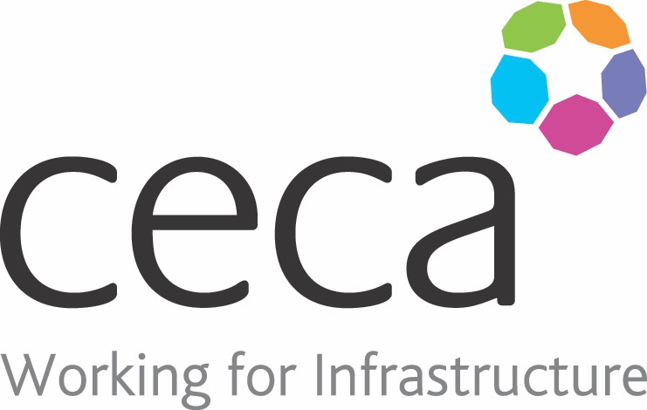
CECA Midlands E Learning

PERSONAL PROTECTIVE EQUIPMENT
This training aims to highlight the importance of using Personal Protective Equipment (PPE), as well as what you can do to ensure your PPE continues to provide the protection you need.
Learning overview:
- What is PPE
- Types of PPE

- Safety signs

Assessment:
This training programme concludes with a 20 question multiple choice test with printable certificate. In addition, brief in-course questionnaires guide the user through the sections of the training, and are designed to reinforce learning and ensure maximum user engagement throughout.

Cost: Registration fee £20 + VAT for full and associate CECA Midlands members.
Award: E learning certificate

Company name: |  | Company contact name:
Company email: |  | Contact tel:
Delegate name: |  | Job title:
Delegate email: |  | Delegate tel:
Accounts Name: |  | Accounts email:

Booking Form – please complete and return to admin@cecamidlands.co.uk one per delegate.
PERSONAL PROTECTIVE EQUIPMENT

