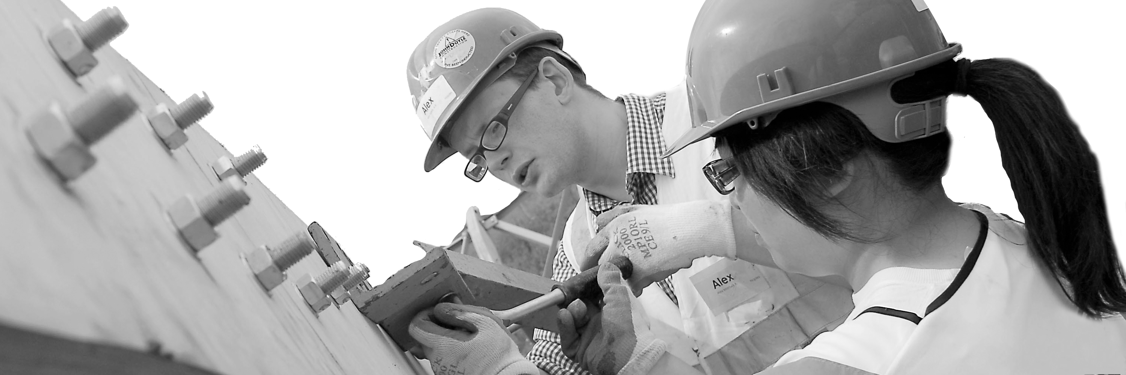
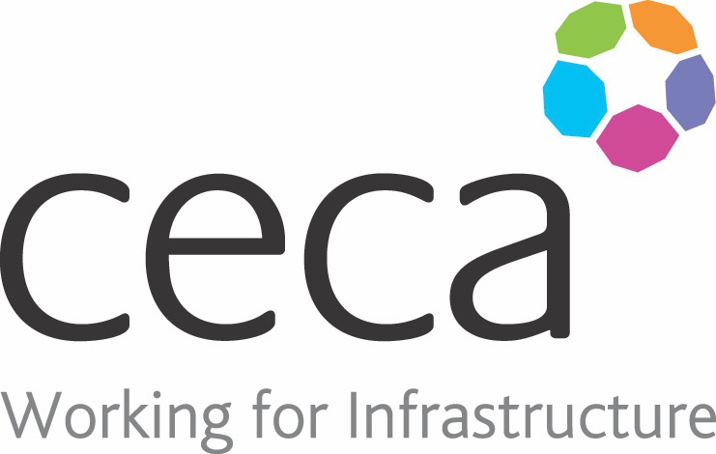
CECA Midlands E Learning

PUWER – WORK EQUIPMENT
PUWER stands for The Provision and Use of Work Equipment Regulations. It provides needed guidelines to demonstrate how you can stay safe when using equipment at work. The regulations place duties on people and companies who own, operate or have any sort of control over work equipment. PUWER also places responsibilities on businesses and organisations whose employees use work equipment.
Our PUWER training aims to educate you on when equipment is suitable for use, safe to use, inspected properly and accompanied by suitable health and safety measures. This course is perfect for working towards compliance with current legislation.

Learning overview:
- PUWER responsibilities
- Safe standard

- Protection and controls

Assessment:
This training programme concludes with a 20 question multiple choice test with printable certificate. In addition, brief in-course questionnaires guide the user through the sections of the training, and are designed to reinforce learning and ensure maximum user engagement throughout.

Cost: Registration fee £20 + VAT for full and associate CECA Midlands members.
Award: E learning certificate

Company name: |  | Company contact name:
Company email: |  | Contact tel:
Delegate name: |  | Job title:
Delegate email: |  | Delegate tel:
Accounts Name: |  | Accounts email:

Booking Form – please complete and return to admin@cecamidlands.co.uk one per delegate.
PUWER - WORK EQUIPMENT

