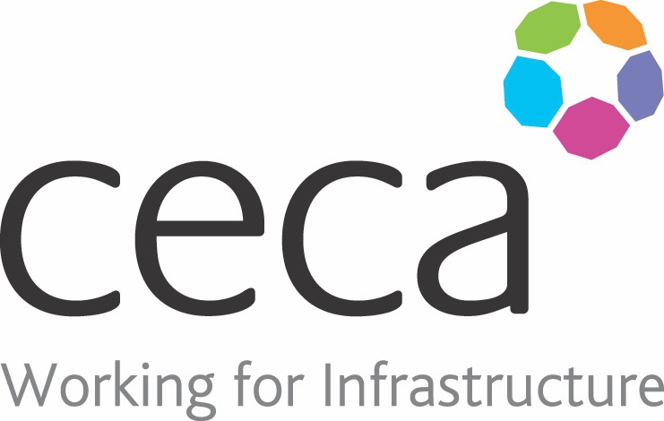
CECA Midlands E Learning

RECOGNISING YOUR VALUE
There are times when we all struggle to recognise our value and what we have to offer - either at work, in the home or to society. But, one way or another, we all actually make a contribution and make a difference – however big or small.
Recognising the value and the benefits that you provide can boost your self-esteem in both your personal and work lives. If you can identify this value within your relationships, it will improve your personal happiness, your purpose or many other aspects of your life.
This course is based on a Japanese philosophy which embodies the idea of happiness in living - the reason you get up in the morning in a positive way. You need to identify four things in your life - what you love, what the world needs, what you are good at and what you can be paid for.
This training is suitable for all levels of employees and managers who all need to be aware of their value and when applied, it will in turn create a more positive workplace culture.

Learning overview:
- The Principals
- The Four Areas of Your Life

Assessment:
This training programme concludes with a 20 question multiple choice test with printable certificate. In addition, brief in-course questionnaires guide the user through the sections of the training, and are designed to reinforce learning and ensure maximum user engagement throughout.

Cost: Registration fee £20 + VAT for full and associate CECA Midlands members.
Award: E learning certificate

Company name: |  | Company contact name:
Company email: |  | Contact tel:
Delegate name: |  | Job title:
Delegate email: |  | Delegate tel:
Accounts Name: |  | Accounts email:

Booking Form – please complete and return to admin@cecamidlands.co.uk one per delegate.
RECOGNISING YOUR VALUE

