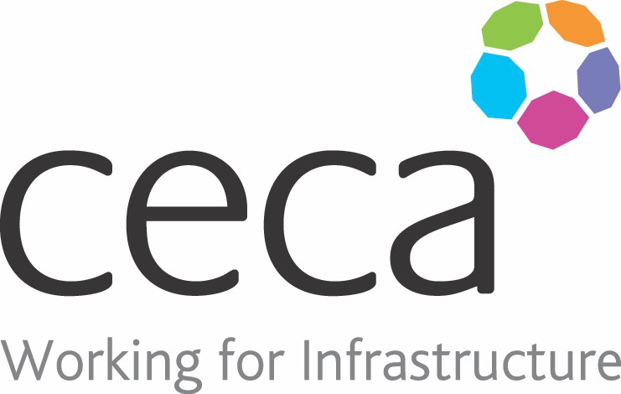
CECA Midlands E Learning

Resilience Training
A study surveying over 300 UK employers, found that 57% of employers see resilience as a key skill needed by their employees.
Resilience can be defined as “That ineffable quality that allows some people to be knocked down by life and come back stronger than ever. Rather than letting failure overcome them and drain their
resolve, they find a way to rise from the ashes.”
Effectively, resilience is the ability to be able to bounce back from difficult situations.
This course will educate your staff on what resilience is, the importance of this skill, how it applies to the workplace, and it touches upon common barriers to building resilience and how they can be overcome. It also focuses on the 5 Pillars of Resilience, Emotional Wellbeing, Future Focus, Inner Focus, Physical Health and Healthy Relationships.
Resilience isn’t necessarily something a person is born with, but anyone can develop the skill, as long as they have the tools and are willing to put in some time and commitment.
​
Learning overview:
- Roles and duties
- Responsibilities of the employer
- Common hand signals

Assessment:
This training programme concludes with a 20 question multiple choice test with printable certificate. In addition, brief in-course questionnaires guide the user through the sections of the training, and are designed to reinforce learning and ensure maximum user engagement throughout.

Cost: Registration fee £20 + VAT for full and associate CECA Midlands members.
Award: E learning certificate

Company name: |  | Company contact name:
Company email: |  | Contact tel:
Delegate name: |  | Job title:
Delegate email: |  | Delegate tel:
Accounts Name: |  | Accounts email:

Booking Form – please complete and return to admin@cecamidlands.co.uk one per delegate.
RESILIENCE TRAINING

