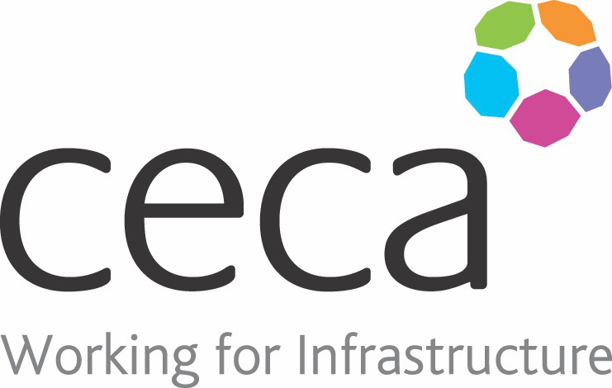
CECA Midlands E Learning

RISK ASSESSMENT IN THE WORKPLACE
This online Risk Assessment training is designed to help businesses comply with Health and Safety regulations, as well as learn to and carry out structured risk assessments in the workplace.
Whatever sector your organisation operates in, risk assessments are a crucial part of ensuring employees are safe from harm and that workplace risks are anticipated and reduced as much as is reasonably possible.
By law, every employer must undertake this kind of assessment for health and safety risks within their working environment. This course gives a clear, structured overview of what a risk assessment is, as well as explaining each stage of how to perform one in a clear, step by step manner.
As well as ensuring legal compliance, this course will show you how to assign ratings to workplace risks, as well as put appropriate control measures in place.

Learning overview:
- Why assess risks?
- When to assess risks

- The 5 steps to risk assessment

- Risk assessment tool

Assessment:
This training programme concludes with a 20 question multiple choice test with printable certificate. In addition, brief in-course questionnaires guide the user through the sections of the training, and are designed to reinforce learning and ensure maximum user engagement throughout.

Cost: Registration fee £20 + VAT for full and associate CECA Midlands members.
Award: E learning certificate

Company name: |  | Company contact name:
Company email: |  | Contact tel:
Delegate name: |  | Job title:
Delegate email: |  | Delegate tel:
Accounts Name: |  | Accounts email:

Booking Form – please complete and return to admin@cecamidlands.co.uk one per delegate.
RISK ASSESSMENT IN THE WORKPLACE

