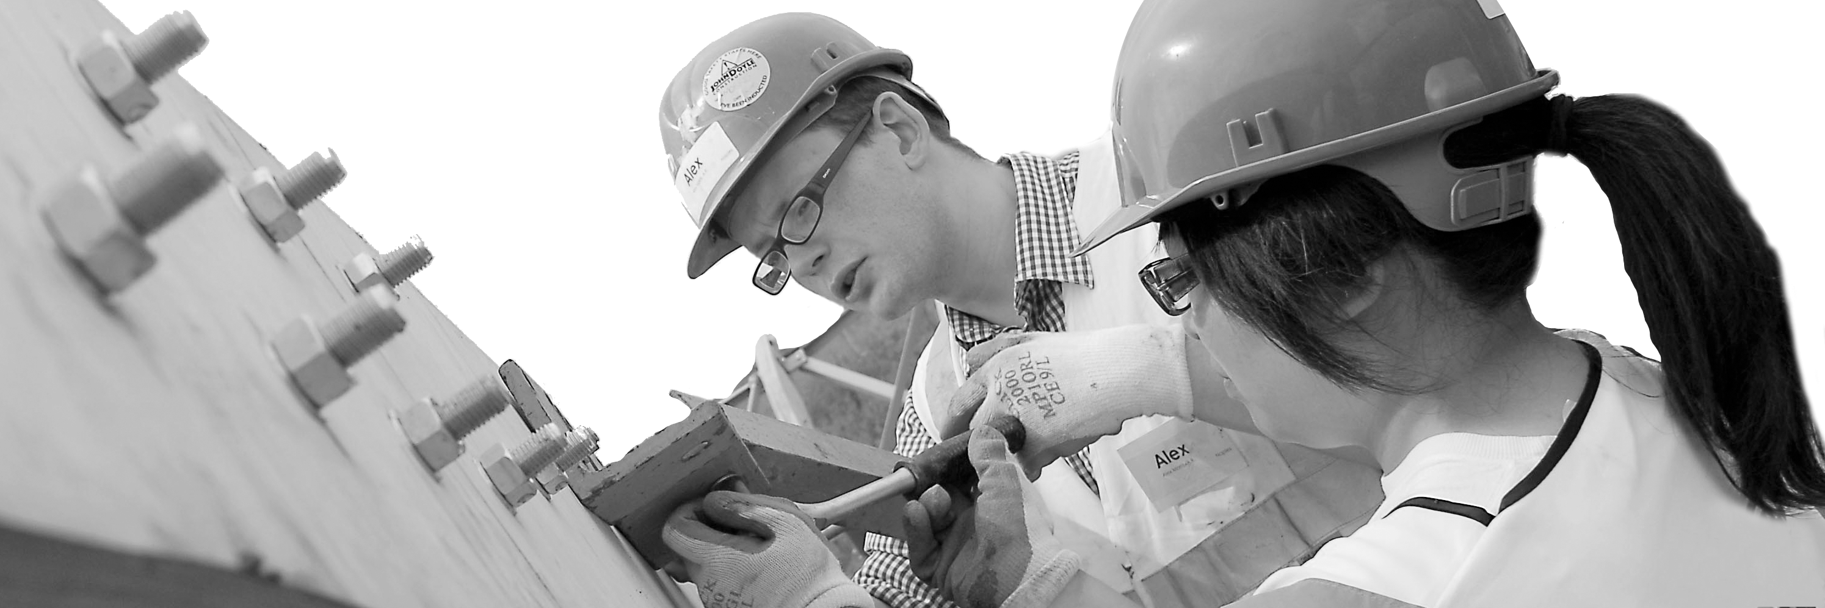
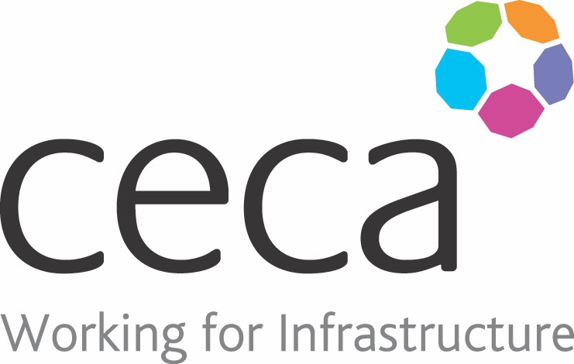
CECA Midlands E Learning

SEXUAL HARASSMENT AWARENESS
With the flurry of sexual harassment claims lately, this course raises awareness, sheds light on the grey areas and provides you with the tools and guidance you need to identify, prevent and remove sexual harassment from the workplace
What is Sexual Harassment? It’s any unwanted and repeated behaviour of a sexual nature.
Your working environment should be a place where you feel safe, appreciated and motivated. The environment should be good for your wellbeing; it should promote dignity and respect.
Yet the statistics show that sexual harassment in the workplace is a huge problem; The Guardian reports that “more than half of women have suffered sexual harassment in the workplace, including sexual assaults and comments about their bodies” and men are victims of this behaviour too!
This Sexual Harassment Awareness course has been created to raise awareness and to provide valuable tools and information to help you identify, prevent and remove sexual harassment from the workplace.
Creating and maintaining a positive workplace culture is everyone’s business – we are all responsible for treating people with kindness and respect.
This course works in conjunction with our Bullying and Harassment in the Workplace for Management and Bullying and Harassment for Employees training courses

Learning overview:
- Sexual harassment awareness
- Identifying sexual harassment
- Confronting and reporting sexual harassment

Assessment:
This training programme concludes with a 20 question multiple choice test with printable certificate. In addition, brief in-course questionnaires guide the user through the sections of the training, and are designed to reinforce learning and ensure maximum user engagement throughout.

Cost: Registration fee £20 + VAT for full and associate CECA Midlands members.
Award: E learning certificate

Company name: |  | Company contact name:
Company email: |  | Contact tel:
Delegate name: |  | Job title:
Delegate email: |  | Delegate tel:
Accounts Name: |  | Accounts email:
Booking Form – please complete and return to admin@cecamidlands.co.uk one per delegate.
SEXUAL HARASSMENT AWARENESS

