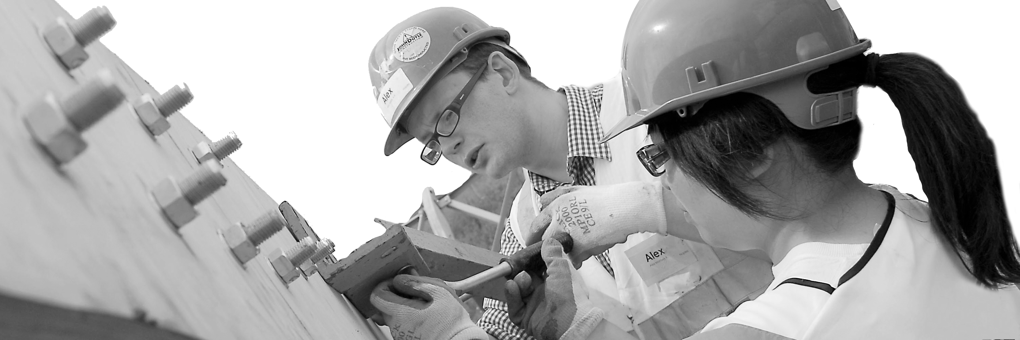
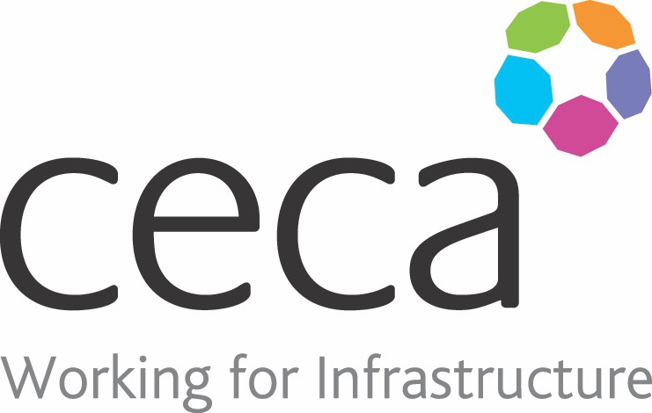
CECA Midlands E Learning

SPILL KITS (CHEMICALS & OILS)
Spills of significant size can pose a large risk to people and the environment. A spill kit contains various absorbent items that can be used when there is a leak or spillage of a hazardous liquid. They are designed to stop the spillage from spreading further and help start a cleanup process.
​There are various sized spill kits that you can buy for your workplace but generally speaking, there are 3 variations of spill kits: a general purpose spill kit, oil and/or fuel spillage kits and chemical spills.
Spill kits should only be opened in emergencies. Most contain the same base products, PPE (personal protective equipment), materials to stop leakages, waste bags and materials to seal drains. Some workplaces may have multiple sizes and multiple purpose spill kits.
When you encounter a spill, the first and most important thing is to protect yourself first. This spill kit Training Course looks at what a spill kit contains, when you need to use it and what procedure to follow when you encounter a spill.

Learning overview:
- Spill Kits
- Dealing with a spill

Assessment:
This training programme concludes with a 20 question multiple choice test with printable certificate. In addition, brief in-course questionnaires guide the user through the sections of the training, and are designed to reinforce learning and ensure maximum user engagement throughout.

Cost: Registration fee £20 + VAT for full and associate CECA Midlands members.
Award: E learning certificate

Company name: |  | Company contact name:
Company email: |  | Contact tel:
Delegate name: |  | Job title:
Delegate email: |  | Delegate tel:
Accounts Name: |  | Accounts email:

Booking Form – please complete and return to admin@cecamidlands.co.uk one per delegate.
SPILL KITS (CHEMICALS & OILS)

