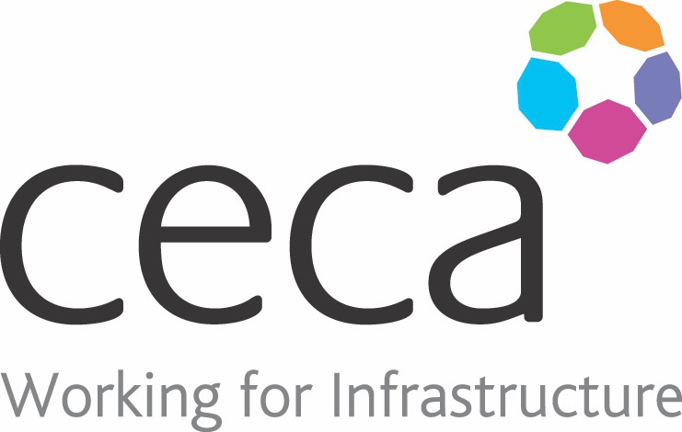
CECA Midlands E Learning

STRESS AWARENESS
Stress is something than can affect all of us – it’s something that can contribute to a great many illnesses, and more working days are lost due to stress than for any other single reason.
Stress Awareness in the Workplace shows you how to take positive steps to prevent stress; it looks at how to stay in control when the pressure is mounting and highlights the tell-tale signs to help you recognise problems before they becomes serious. It also provides strategies to put in place to prevent pressure getting out of control – suggesting ways to change daily routines and learned behaviours to allow a better and more productive working life.
Statistics show there are around 400,000 cases of work-related stress in Great Britain each year, with nearly 11 million working days lost – that’s over a month for each case.

Learning overview:
- Are you stressed?
- Fight or flight?

- State of stress

- Stress factors

- Stress strategies

Assessment:
This training programme concludes with a 20 question multiple choice test with printable certificate. In addition, brief in-course questionnaires guide the user through the sections of the training, and are designed to reinforce learning and ensure maximum user engagement throughout.

Cost: Registration fee £20 + VAT for full and associate CECA Midlands members.
Award: E learning certificate

Company name: |  | Company contact name:
Company email: |  | Contact tel:
Delegate name: |  | Job title:
Delegate email: |  | Delegate tel:
Accounts Name: |  | Accounts email:

Booking Form – please complete and return to admin@cecamidlands.co.uk one per delegate.
STRESS AWARENESS

