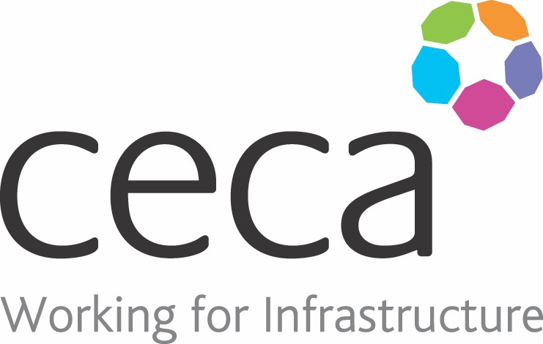
CECA Midlands E Learning

TIME MANAGEMENT
Once time has gone – it’s gone! Whilst it is our most precious resource most people are not very good at using it wisely. And how many of us suffer from other people imposing their time-frames on us?
It has been estimated that as much as 80% of our time is spent dealing with matters that are ‘urgent’, or are trivial tasks, or simply those that are easy to do – and we often can’t find the time to do the important work that will make a difference to us and the organisation.
This course will equip you with the tools you need to take control of your time so that you will be able to spend more of it doing the things that really matter. It will teach you how to plan your goals effectively, manage your schedule and avoid distractions and the pitfalls of procrastination.
There’s no science to time management – it’s an art that we can develop, so this course offers a number of different tips and strategies for you to choose from so, no matter what you have been doing up until now, there will be something for you that will help.

Assessment:
This training programme concludes with a 20 question multiple choice test with printable certificate. In addition, brief in-course questionnaires guide the user through the sections of the training, and are designed to reinforce learning and ensure maximum user engagement throughout.

Cost: Registration fee £20 + VAT for full and associate CECA Midlands members.
Award: E learning certificate

Company name: |  | Company contact name:
Company email: |  | Contact tel:
Delegate name: |  | Job title:
Delegate email: |  | Delegate tel:
Accounts Name: |  | Accounts email:

Booking Form – please complete and return to admin@cecamidlands.co.uk one per delegate.
TIME MANAGEMENT

