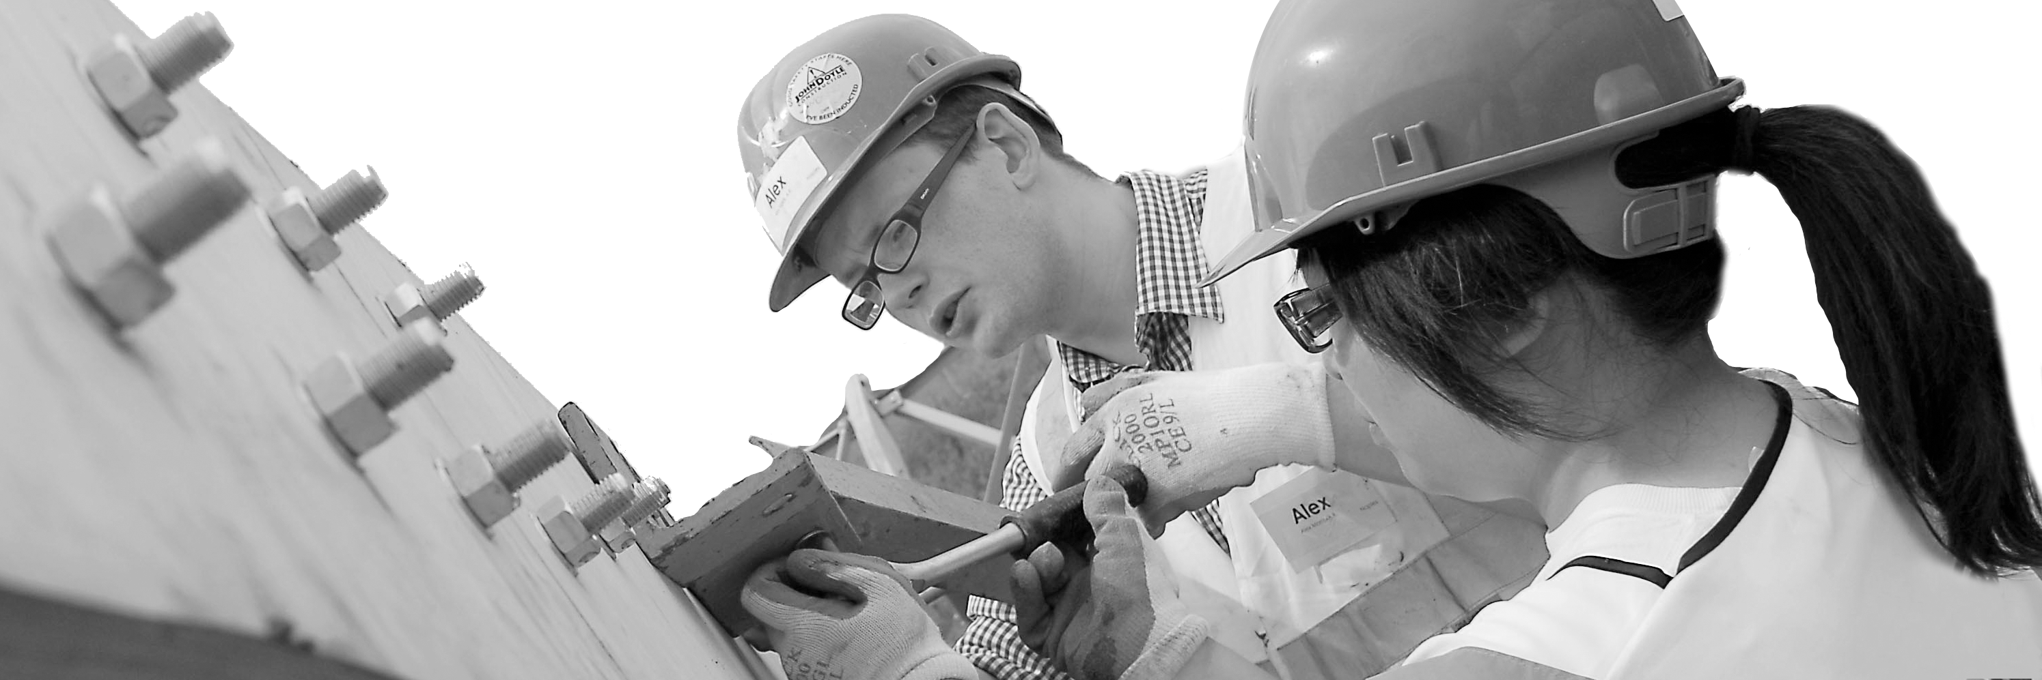
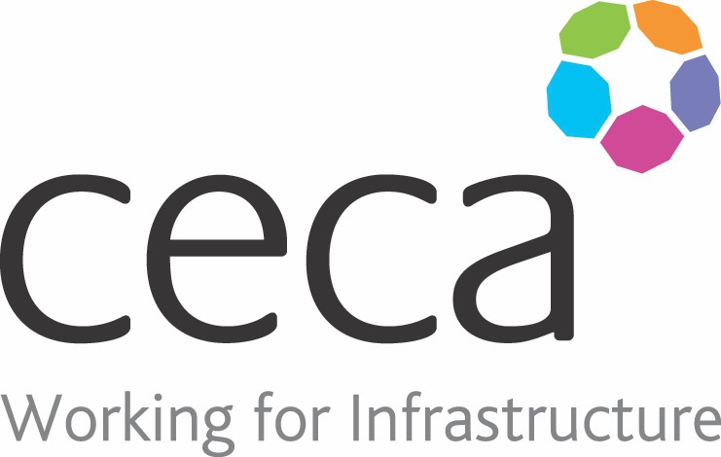
CECA Midlands E Learning

UNCONSCIOUS BIAS FOR EMPLOYEES
This training has been created to identify, challenge and reduce unconscious bias in the workplace. Workplaces with less bias at all tend to cultivate fairer, more diverse and more successful cultures.
Cases of Unconscious Bias happen every single day in UK workplaces and they can have a seriously negative impact on staff morale and productivity.
We are often unaware of our unconscious biases but they are stored away in our minds and still affect the way we think and how we behave.
An example of a common unconscious bias is Conformity Bias, which is when we behave similarly to others in a group, even if it goes against what we actually believe.
This Unconscious Bias Training has been created to identify your own unconscious biases as well as any others that already exist in your workplace. It looks at things such as how they affect workplace relationships, decision making and workplace culture.
This course works in conjunction with Unconscious Bias for Management, and it’s the perfect partner for both Equality & Diversity Training, and Bullying & Harassment for Employees.

Learning overview:
- Unconscious bias in the workplace
- Strategies for reducing bias

- What’s next

Assessment:
This training programme concludes with a 20 question multiple choice test with printable certificate. In addition, brief in-course questionnaires guide the user through the sections of the training, and are designed to reinforce learning and ensure maximum user engagement throughout.

Cost: Registration fee £20 + VAT for full and associate CECA Midlands members.
Award: E learning certificate approved by ROSPA

Company name: |  | Company contact name:
Company email: |  | Contact tel:
Delegate name: |  | Job title:
Delegate email: |  | Delegate tel:
Accounts Name: |  | Accounts email:

Booking Form – please complete and return to admin@cecamidlands.co.uk one per delegate.
UNCONSCIOUS BIAS FOR EMPLOYEES

