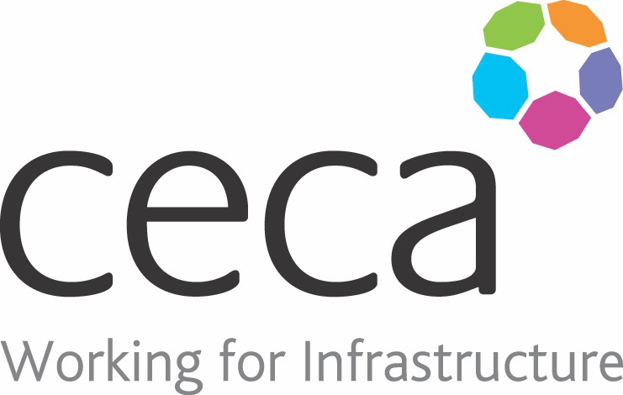
CECA Midlands E Learning

UNCONSCIOUS BIAS FOR MANAGERS
Because having pre-conceived ideas about a person can cause problems in the workplace, our Unconscious Bias Training for Managers has been created for management to identify, challenge and reduce bias in the workplace, so they can cultivate a fairer, more diverse and successful organisation.
A bias is a judgement or opinion that’s based on our own thoughts about someone or something – rather than the reality or the facts. Biases are natural (we can’t help having them) but they shouldn’t go unchallenged.
We have conscious biases which are biases we’re aware of, and we have unconscious biases which we’re unaware of – but they are stored away in our mind and they still affect what we think and how we behave.
This Unconscious Bias Training course has been created to explain how you can identify your own unconscious biases and any that exist in your workplace. It looks at how they affect decision making, working relationships and your organisation’s culture. Fundamentally, this training offers practical tools for reducing the negative impact that unconscious bias can have on your organisation.
By identifying, challenging and reducing bias, management can create a more communicative, diverse and successful workforce.
This course works in conjunction with Unconscious Bias for Employees, and it’s the perfect partner for both Equality & Diversity, and Bullying & Harassment for Managers.

Learning overview:
- Unconscious bias in the workplace
- Strategies for reducing bias
- Management responsibilities

- What’s next

Assessment:
This training programme concludes with a 20 question multiple choice test with printable certificate. In addition, brief in-course questionnaires guide the user through the sections of the training, and are designed to reinforce learning and ensure maximum user engagement throughout.

Cost: Registration fee £16 + VAT for full and associate CECA Midlands members.
Award: E learning certificate approved by ROSPA

Company name: |  | Company contact name:
Company email: |  | Contact tel:
Delegate name: |  | Job title:
Delegate email: |  | Delegate tel:
Accounts Name: |  | Accounts email:

Booking Form – please complete and return to admin@cecamidlands.co.uk one per delegate.
UNCONSCIOUS BIAS FOR MANAGERS

