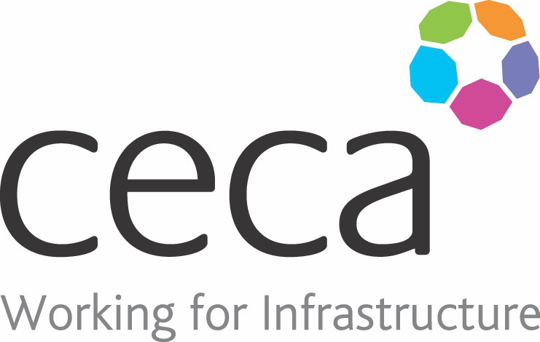
CECA Midlands E Learning

WHISTLEBLOWING
Providing employees with the right tools and information when it comes to Whistleblowing is essential for an employer to show that they are equipping their staff to deal with any cause for concerns.
There are a number of laws in place to protect whistleblowers and they were created to support these people if they faced retaliation at work or the threat of dismissal after coming forward. Concerns of wrongdoing within a company can be brought forward both internally and externally. This course will advise employees on what procedures to follow and when you should raise your concerns.
This Whistleblowing course will provide information on what a whistleblower is, the law surrounding whistleblowing and what constitutes whistleblowing. Whistleblowing Training is essential for any organisation so that the correct procedures are in place should someone choose to come forward.
Through this Whistleblowing training, we will equip employees with the information about what they should do if they put forward concerns to an internal or external party through 3 easy steps.

Learning overview:
- Roles and duties
- Responsibilities of the employer
- Common hand signals

Assessment:
This training programme concludes with a 20 question multiple choice test with printable certificate. In addition, brief in-course questionnaires guide the user through the sections of the training, and are designed to reinforce learning and ensure maximum user engagement throughout.

Cost: Registration fee £20 + VAT for full and associate CECA Midlands members.
Award: E learning certificate

Company name: |  | Company contact name:
Company email: |  | Contact tel:
Delegate name: |  | Job title:
Delegate email: |  | Delegate tel:
Accounts Name: |  | Accounts email:

Booking Form – please complete and return to admin@cecamidlands.co.uk one per delegate.
WHISTLEBLOWING

