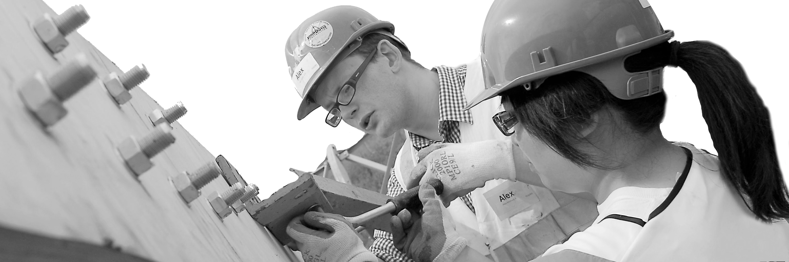
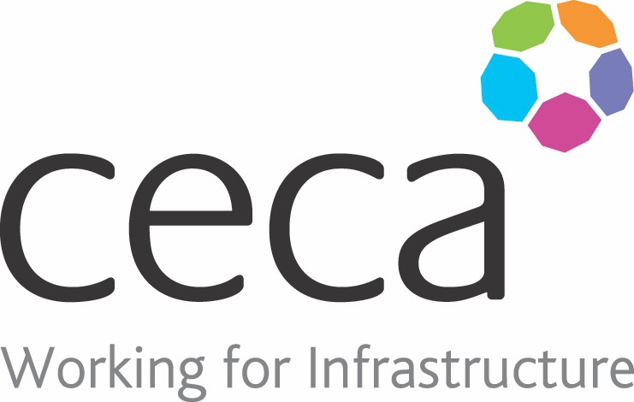
CECA Midlands E Learning

WORKING AT HEIGHT AWARENESS
Every year falls from height cause the most deaths at work and the second highest number of major injuries.
This course is designed as an introduction to this key site safety topic – whether you work in Building and Construction, or are involved in any kind of installation or maintenance that requires you to work at a height.
Working at Height means working somewhere where there is the potential to fall from one level to a level below: It’s not just falling from a ladder or scaffolding, it’s also falling down holes and falling through fragile surfaces.
The Work at Height Regulations 2005 and the HSE guide to these regulations are very clear about what must be done to stay safe when working at height, and this training programme follows the laws and guidance to ensure that everyone knows how to stay safe.

Learning overview:
- Responsibility
- Risk
- Choosing equipment

Assessment:
This training programme concludes with a 20 question multiple choice test with printable certificate. In addition, brief in-course questionnaires guide the user through the sections of the training, and are designed to reinforce learning and ensure maximum user engagement throughout.

Cost: Registration fee £20 + VAT for full and associate CECA Midlands members.
Award: E learning certificate approved by ROSPA

Company name: |  | Company contact name:
Company email: |  | Contact tel:
Delegate name: |  | Job title:
Delegate email: |  | Delegate tel:
Accounts Name: |  | Accounts email:

Booking Form – please complete and return to admin@cecamidlands.co.uk one per delegate.
WORKING AT HEIGHT AWARENESS

