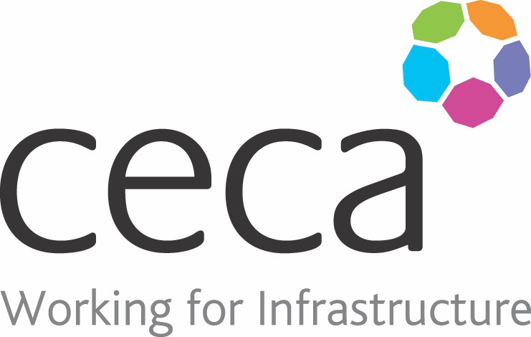
CECA Midlands E Learning

WORKSHOP SAFETY
This course is for anyone who works in a workshop and will give them an overview about working safely, looking at why accidents happen and how they can be prevented.
Workshop safety training is vital to ensuring that your staff follow best practices and remain safe in their workplace. No two workshops are the same, as each will have different hazards and machinery and so this course concentrates on general safety awareness, safe working habits and safe operating procedures.
​The course covers specific hazards that may be found in a workshop, such as dangerous equipment and hazardous substances. For each type of hazard, it explains who needs to know about that particular type of hazard and what the dangers are provided.
​However, in order to administer medication to residents in a care home you need formal training from an NHS practitioner, this course is not a substitute for this training.

Learning overview:
- Your workshop
- Safety signs
- Preventing accidents

Assessment:
This training programme concludes with a 20 question multiple choice test with printable certificate. In addition, brief in-course questionnaires guide the user through the sections of the training, and are designed to reinforce learning and ensure maximum user engagement throughout.

Cost: Registration fee £20 + VAT for full and associate CECA Midlands members.
Award: E learning certificate

Company name: |  | Company contact name:
Company email: |  | Contact tel:
Delegate name: |  | Job title:
Delegate email: |  | Delegate tel:
Accounts Name: |  | Accounts email:

Booking Form – please complete and return to admin@cecamidlands.co.uk one per delegate.
WORKSHOP SAFETY

