CECA Midlands Annual Golf Event 2023
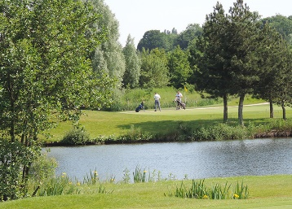
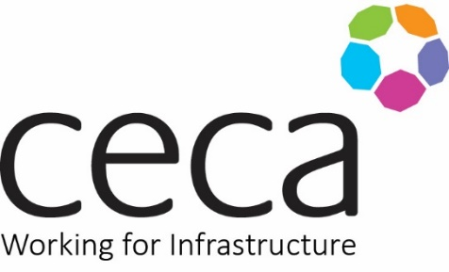
______________________________________________

An opportunity to gather colleagues and associates for an afternoon at Droitwich Golf and Country Club, Worcestershire. A mature 18 hole parkland course features superbly maintained and tree-lined fairways. The greens, noted to be among the very best in the surrounding area. This beautiful course is a challenge to golfers of all abilities, though not long – it stretches to 5,976 yards off the white tees- it is still a test for the more talented player.
Wednesday 5 July 2023
Golfers Order of the day
12pm Soup and Sandwiches
1pm Tee off
6pm Dinner & Prizes
Course Fees
Golfers - Two Players £135 + VAT
This event is also open to non-members – to book please complete the booking form below and include a PO number for invoice. We regret that tickets are non-refundable. Return to office@cecamidlands.co.uk
Player 1 name: |  | Player 2 name:
Contact email: |  | Contact email:
Company name: |  | Company name:
Handicap: |  | Handicap:
Staying for dinner?  Yes/No |  | Staying for dinner?  Yes/No
Payment details:  Company name: |  | PO Number:
Company Accounts Dept Contact Name: |  | Email/Telephone:
Company address:

