Press Release | 20-04-2023

Seawork – where the commercial marine industry gathers.....
The 24th edition of Europe’s largest commercial marine and workboat exhibition returns to Mayflower Park on 13-15 June 2023,
Throughout the year, the Seawork team collaborates with the key organisations and associations whose member’s help set and drive the business agenda. Their presence at Seawork ensures exhibitors will meet the visitors that matter.
In 2023, Seawork is delighted to welcome back over 45 associations and supporting organisations, including the following:
International Harbour Masters Association; Big Blue Ocean Clean Up; Royal Institution of Naval Architects (RINA); International Ship Engineering Service Association Ltd (ISES); Association of Brokers and Yacht Agents (ABYA); Yacht Designers and Surveyors Association (YDSA)
UK Department for Business and Trade (DBT) - The National Shipbuilding Office (NSO), the UK Government’s Ministry of Defence (MOD) department responsible for all UK Defence Equipment and Support (DE&S) projects and the Department for Business and Trade (DBT) Maritime Capability Campaign Office (MCCO) (formerly part of the Department for International Trade), are all available on the UK Government Zone stand and the MOD will also be presenting its annual procurement session in the Seawork Conferences on Tuesday 13 June at 1100.
The Seafarers Charity – the official Seawork Charity for 2023 - welcomes visitors to its stand and is inviting a variety of its supporters to visit them at the exhibition.
Society of Maritime Industries (SMI) – presents both members and non-members in its SMI Shipyard Pavilion pods and hosts a members networking event on Wednesday 14 June, as well as sponsoring the Innovations Showcase.
The Workboat Association – presents the Workboat Pavilion with members on the stand, as well as hosting the following events:
- Member networking in the pavilion on Wednesday 14 June;
- Get Set for Workboat 2050 Series 3 Session 5 in the Seawork Conference Centre on Tuesday 13 June;
- The Safety Forum focusing on emergency preparedness.
UK Harbour Masters Association (UKHMA) – will be represented at the European Commercial Marine Awards on Tuesday 13 June and at the Decarbonisation Sessions on Wednesday 14 June.
The Association of Diving Contractors (ADC) – presents the Divework Pavilion at Seawork, showcasing the popular Dive Tank with its varied demonstrations. ADC also hosts a reception at the Divework pavilion on the afternoon of Wednesday 14 June.
British Tug Owners Association - hosts a meeting at Seawork on Wednesday 14 June 1030-1230 for its members and supports the Careers and Training event on Thursday 15 June, promoting the association’s apprenticeship schemes.
Civil Engineering Contractors Association (CECA) - welcomes visitors to its stand in the Marine Civils Pavilion and hosts the following sessions in the conference rooms on Wednesday 14 June:
- 1000 – 1100 Environment Group & Flood, Marine Group member only meeting
- 1100 – 1300 Understanding the power of Tidal Projects for Marine Civils – everyone welcome
Chartered Institution of Civil Engineering Surveyors (CICES) – runs a membership workshop on its stand in the Marine Civils pavilion for potential new members and for existing members to ensure they are making the most of all that is on offer.

Both the CECA Southern Foundations Group and CICES are supporting the Careers and Training event on Thursday 15 June.
Institution of Civil Engineers (ICE) - Seawork and Marine Civils is one of the official supporters of ICE Coasts, Marines Structures and Breakwaters 2023, taking place in April 2023 in Portsmouth, UK and ICE welcomes their members to Seawork in June.
International Institute of Marine Surveying (IIMS) – welcomes visitors to its stand next to the Workboat Pavilion and will be speaking at the Careers and Training event on Thursday 15 June, highlighting its apprenticeships and training courses.
International Jack Up Barge Owners Association (IJUBOA) - welcomes visitors and members to its stand in the Marine Civils pavilion and will hold its AGM at Seawork on Wednesday 14 June. This is followed by an invitation-only dinner in the Waterfront Restaurant.
National Coastwatch Institution (NCI) - welcomes visitors to its exhibition trailer to promote the organisation, recruit members and highlight the role of the Watch Station.
To meet with all of these organisations and associations, register at Seawork.com to plan your visit and receive fast-track access to the exhibition.

To exhibit contact the commercial marine sales team:
T: +44 1329 825 335
E: sales@seawork.com
-ends-
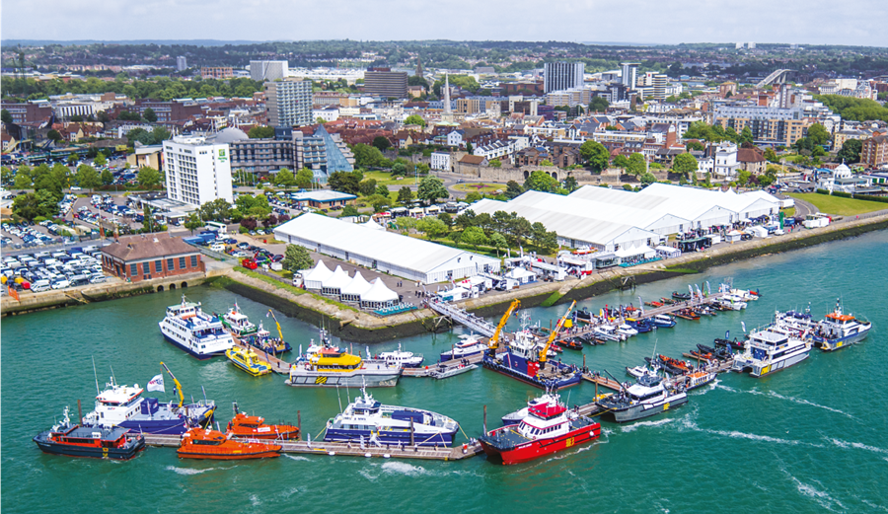
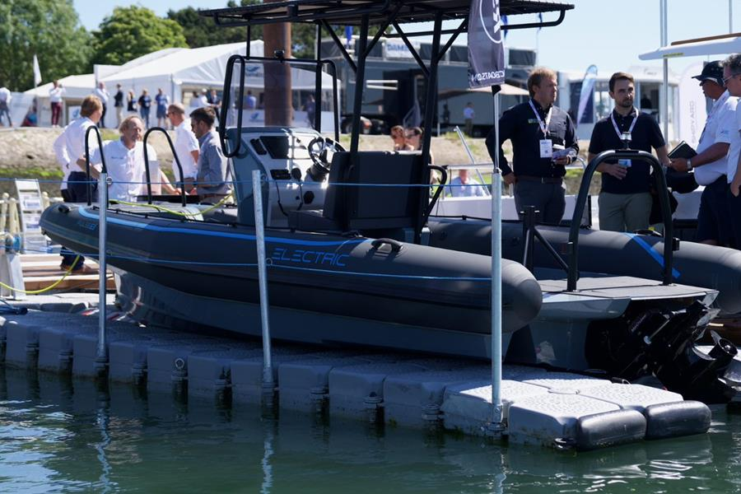

About Seawork
Seawork2023 is in-person 13-15 June in Southampton. It is supported online by Seawork.com which is now open for business 365 days a year.
Seawork2023, the leading European commercial marine exhibition, is held at Mayflower Park in Southampton, Hampshire, UK.
Exhibition Address: Mayflower Park venue in Southampton, SO14 2AN, United Kingdom
Now in its 24th year, Seawork2023 offers a unique combination of undercover exhibition space, open air demonstrations and floating displays.
.
Marine Civils is co-located with Seawork.
The exhibition encompasses:
12,000m² of undercover space in purpose-built exhibition halls
More than 70 vessels and floating exhibits available for demonstrations on the water
A Quayside for large exhibits and outdoor demonstrations
Excellent conference and meeting facilities
Visit www.seawork.com further information
About Mercator Media Ltd
Established in 1989 Fareham-based Mercator Media Ltd (MML) is an events, magazines and online B2B media business, specialising in the commercial marine sector. It is a global leader in the creation of integrated marketing strategies for clients using a range of channels including print, online, events and research. Mercator’s magazines, events and online resources are produced by industry experts dedicated to providing the critical insight, analysis and relevant connections sought by business professionals who are advancing their specific fields.
Visit www.mercatormedia.com for further information.
Images: Hi-res images are available upon request. Unless stated, please credit Mercator Media.
Contact: E; marketing@mercatormedia.com T: +44 1329 825 335
Issued: 20 April 2023
MERCATOR MEDIA LTD Spinnaker House, Waterside Gardens, Fareham, Hampshire PO16 8SD, UK
Tel: +44 1329 825335 | Fax: +44 1329 550192

