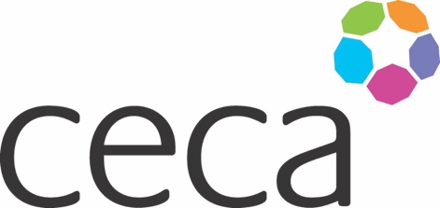
Midlands ANNUAL DINNER 2024
CECA MIDLANDS AWARDS
APPLICATION FORM
CLIENT TEAM OF THE YEAR AWARD 2024

Our Client Team of the Year awards is aimed at recognising client teams who deliver a high standard of collaboration and partnership work whilst supporting the construction team and sub-contractors to deliver the project. The submission should highlight the client’s team’s contribution to the effectiveness of the project, including their approach or contribution to achieving solutions, developing, or supporting innovation, timely decision making and effective communication.

This category is open to CECA Midlands member’s that achieved completion, or equivalent, during the period between July 2023- June 2024.

The Awards celebrate the best client team of the year, and the entries should reflect that. The entry should have one main proposer but feel free to provide details of other relevant parties such as the principal and, or specialist contractors and your client team. (With written permission if you are providing details).

Criteria
Each written application should be accompanied by at least one photograph of the completed project and may be supported by up to three different photographs of the project under construction along with endorsement if appropriate. (Maximum of 1200 words).
The submission must endeavour to meet the following criteria – ideally incorporate these criteria as headings or make them easy to identify:

- Client Team Project excellence
- Achieving Solutions
- Timely decision making and effective communication/relationships
- Innovation and sharing of good practice
- Any other stand-out performance that particularly merits this award

Award
The Award will be recognised by an engraved trophy and certificate presented at the Annual Dinner on 12 September 2024. Judging will be undertaken by unassociated industry representatives.

Closing date
All submissions must be emailed to office@cecamidlands.co.uk to arrive by 5pm, 14 June 2024.
Midlands ANNUAL DINNER 2024

NOMINATING COMPANY DETAILS
Company name:
Contact name: (author)
Contact job title:
Contact telephone:
Contact email:

SUBMISSION (below)

