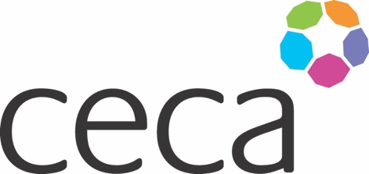
Midlands ANNUAL DINNER 2024
CECA MIDLANDS AWARDS
APPLICATION FORM
LIFETIME ACHIEVEMENT AWARD 2024

The CECA Midlands awards celebrate the best people and projects, and entries should reflect that. This special lifetime achievement award recognises a construction professional who has made an outstanding contribution to the sector.

The candidates will be based on nominations from a senior individual within the organisation. The nominated individual will have consistently made an outstanding contribution to the industry and represents a 'model of excellence' across their entire career.

The entry should have one main proposer but feel free to provide details of other relevant parties. (With written permission if you are providing details).

Criteria
Each written application can be accompanied by supporting evidence if relevant and a photograph must be provided. (Maximum of 1200 words).
The submission must endeavour to meet the following criteria – ideally incorporate these criteria as headings or make them easy to identify:

- Long service within the construction industry
- Evidence of mentoring and leadership
- Continual improvement throughout their career
- Having kept abreast and at the forefront of innovation and industry advancement
- An individual who has embraced fairness and diversity throughout their career
- An outstanding individual who is both liked and respected across the industry

Award
The Award will be recognised by an engraved trophy and certificate presented at the Annual Dinner on 12th September 2024. Judging will be undertaken by unassociated industry representatives.

Closing date
All submissions must be emailed to office@cecamidlands.co.uk to arrive by 5pm 14th June 2024.

Midlands ANNUAL DINNER 2023

NOMINATING COMPANY DETAILS

Company name:
Contact name: (author)
Contact job title:
Contact telephone:
Contact email:

EMPLOYEE DETAILS

Employee’s name:
Job title:
Length of service:
Contact telephone:
Contact email:
Contact telephone:

SUBMISSION (below)

