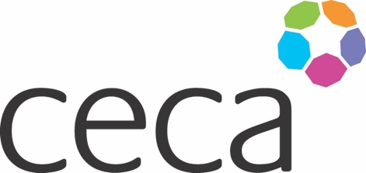
Midlands ANNUAL DINNER 2024
CECA MIDLANDS AWARDS
APPLICATION FORM

MOST PROMISING APPRENTICE OF THE YEAR 2024

The CECA Midlands awards celebrate the excellent people and projects within the industry and entries should reflect this. The MOST PROMISING APPRENTICE of the year award is your opportunity to recognise the excellent work of an apprentice and support them on their journey of work. Their job role or level of apprenticeship is irrelevant, what is important is their enthusiasm, dedication, and effort that they put into their work along with their personal development. They should have joined our industry on or after 1 July 2023. As nominator you should be able to demonstrate how, specifically, they have engaged in their learning and work, how they are standing out in your organisation, and making a difference to the people they work with and contributing to the overall business performance.

They will be judged on all round ability - not only academic and work-related achievements - but also their enthusiasm for your organisation and the civil engineering industry.

Entries should be submitted by their employer and should include a commendation from a line manager or mentor within their organisation.

Criteria
Each written application can be accompanied by a photograph/s if relevant and, or other supporting evidence. (Maximum of 1200 words please adhere to this wordcount and submit in Word format not PDF).
The submission must endeavour to meet the following criteria – ideally incorporate these criteria as headings or make them easy to identify:

- An outline of their specific work journey and development with details of how the nominee is engaging with the apprenticeship process
- Dedication and, or teamwork with illustrative examples
- Helping and supporting others
- Academic or work-related success
- A stand-out performance that particularly merits this award – the ‘extra mile’ factor

Award
The Award will be recognised by an engraved trophy and certificate presented at the Annual Dinner on 12th September 2024. Judging will be undertaken by unassociated industry specialists and representatives.

Closing date
All submissions must be emailed to office@cecamidlands.co.uk to arrive by 5pm, 14th June 2024.
Midlands ANNUAL DINNER 2024

NOMINATING COMPANY DETAILS

Company name:
Contact name: (author)
Contact job title:
Contact telephone:
Contact email:
Contact signature:
Senior Director’s name:
Senior Director’s signature:
(If different from above)
Date of submission:

EMPLOYEE DETAILS

Employee’s name:
Job title:
Length of service:
Contact telephone:
Contact email:
Contact telephone:

SUBMISSION (below)

