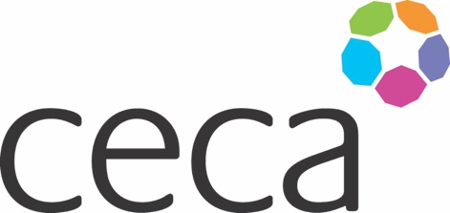
Midlands ANNUAL DINNER 2024
CECA MIDLANDS AWARDS
APPLICATION FORM
PROJECT OF THE YEAR: VALUE Up to £3m

Our project of the year award is aimed at bringing recognition to construction teams who deliver a high standard of work on all levels, keep to budget and gain client satisfaction.

This category is open to CECA Midlands member’s smaller projects with a budget of up to £3m that achieved completion, or equivalent, during the period between July 2023
– June 2024.

The Awards celebrate the best of construction projects and the entries should reflect that.
The entry should have one main proposer but feel free to provide details of other relevant parties such as the client, principal and, or specialist contractors and your main team. (With written permission if you are providing details).

Criteria
Each written application should be accompanied by at least one photograph of the completed project and may be supported by up to three different photographs of the project under construction along with client endorsement if appropriate. (Maximum of 1200 words).
The submission must endeavour to meet the following criteria – ideally incorporate these criteria as headings or make them easy to identify:

- Client satisfaction
- Project excellence
- Health and safety performance
- Sustainability
- Completion on time and to budget
- Supply chain best practice
- Innovation
- Any other stand-out performance that particularly merits this award

Award
The Award will be recognised by an engraved trophy and certificate presented at the Annual Dinner on 12 September 2024. Judging will be undertaken by unassociated industry representatives.

Closing date
All submissions must be emailed to office@cecamidlands.co.uk to arrive by 5pm 14th June 2024.
Midlands ANNUAL DINNER 2024

NOMINATING COMPANY DETAILS

Company name:
Contact name: (author)
Contact job title:
Contact telephone:
Contact email:

SUBMISSION (below)

