Galley Hill Road
Contractor Workshop Briefing Pack

5 June 2026

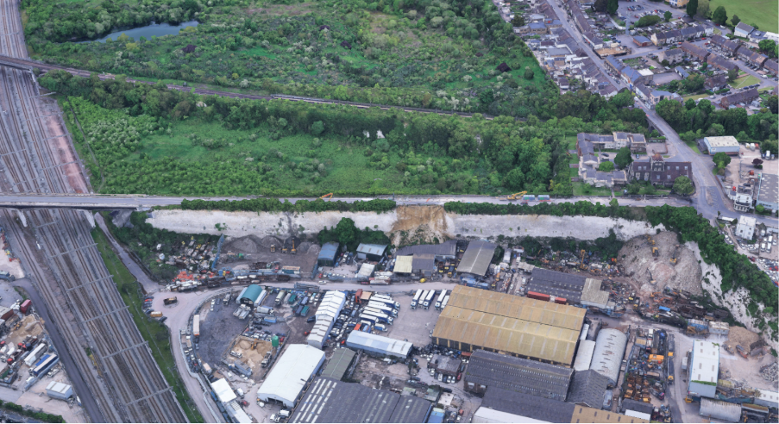

Galley Hill Road
Contractor Workshop – Pre-Workshop Feedback Form

Purpose
This form captures contractor views on the feasibility, risks and buildability of the shortlisted options ahead of the workshop. Responses will inform structured discussion and option appraisal.

Respondent Information
Company:
Name:
Role:
Contact Information:

General Observations (All Options)
Key risks across all options
Key constraints to delivery
Programme considerations / critical path activities
High-Level View on Land Take

Opportunities for optimisation or simplification

Option 1 – Three-span bridge over retained chalk spine
Constructability / overall feasibility
Temporary works, logistics and temporary land take (e.g. working platforms, haul routes, lifting, stockpiling, treatment)
Key risks / key constraints
Programme implications
Opportunities for improvement or alternative approaches
Deliverability Rating ( 1 (Poor) – 4 (High)) | ☐ 1 ☐ 2 ☐ 3 ☐ 4

Option 2 – Four-span bridge over excavated chalk spine
Constructability / overall feasibility
Temporary works, logistics and temporary land take (e.g. working platforms, haul routes, lifting, stockpiling, treatment)

Key risks / key constraints
Programme implications
Opportunities for improvement or alternative approaches
Deliverability Rating ( 1 (Poor) – 4 (High)) | ☐ 1 ☐ 2 ☐ 3 ☐ 4

Option 3 – Five-span bridge over excavated chalk spine
Constructability / overall feasibility
Temporary works, logistics and temporary land take (e.g. working platforms, haul routes, lifting, stockpiling, treatment)

Key risks / key constraints
Programme implications
Opportunities for improvement or alternative approaches
Deliverability Rating ( 1 (Poor) – 4 (High)) | ☐ 1 ☐ 2 ☐ 3 ☐ 4

Option 4 – Reinforced Soil Solution
Constructability / overall feasibility
Temporary works and logistics (e.g. working platforms, haul routes, lifting, stockpiling, treatment)
Key risks / key constraints
Programme implications
Opportunities for improvement or alternative approaches
Deliverability Rating ( 1 (Poor) – 4 (High)) | ☐ 1 ☐ 2 ☐ 3 ☐ 4

Comparative Feedback
Most deliverable option and why
Highest risk option and why
Land Take and Logistics
Any assumptions in the report considered unrealistic or requiring further validation
Key recommendations for next design stage / contractor workshop focus areas

Additional Comments

Ranking
Option | Rank (1-4)
Option 1 – Three-span bridge over retained chalk spine
Option 2 – Four-span bridge over excavated chalk spine
Option 3 – Five-span bridge over excavated chalk spine
Option 4 – Reinforced Soil Solution

Arcadis (UK) Ltd
80 Fenchurch Street
London
EC3M 4BY
United Kingdom
Phone: +44 207 812 2000

www.arcadis.com

